Manil S. Malla

wcrecent@@gmail.com

Abstract

[Draw your reader in with an engaging abstract. It is typically a short summary of the document.   
When you’re ready to add your content, just click here and start typing.]

E Commerce Lab 1

Basic XAMPP

* Questions

1. Create a database “ecom” in XAMPP.
2. Create two tables

* Solutions
* Using XAMPP Shell

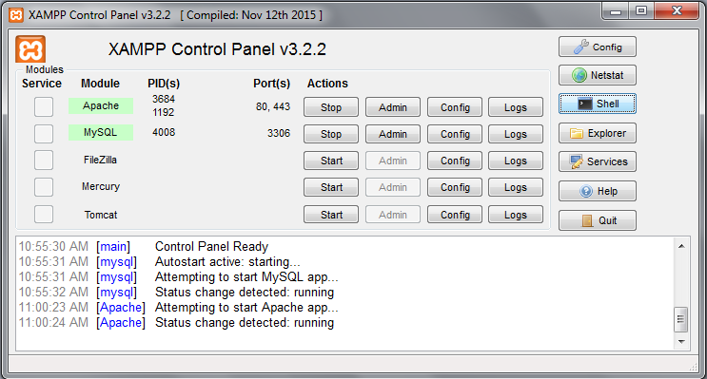

* Open XAMPP and select Shell.

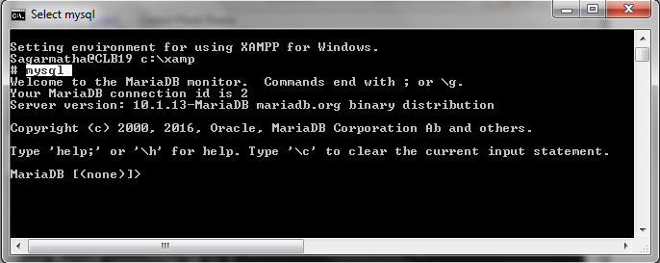

* Type “mysql”

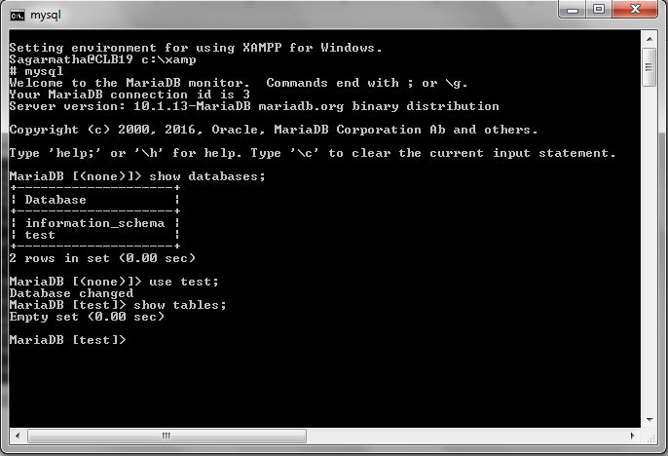

* Use commands like “show databases;”, “use <test>;”, “show tables;” etc.
* Using PHP MY ADMIN

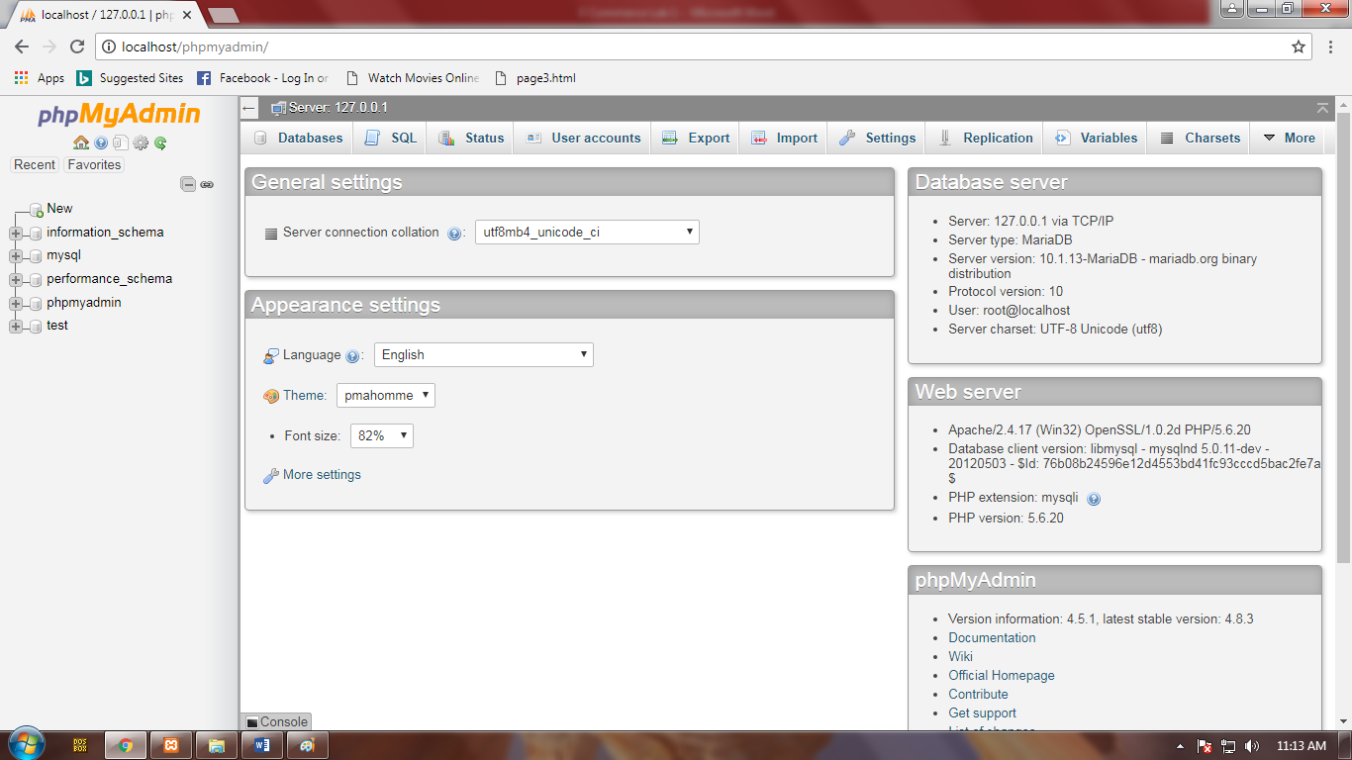

* Type <http://localhost/phpmyadmin/> in a browser to access PHP MY ADMIN

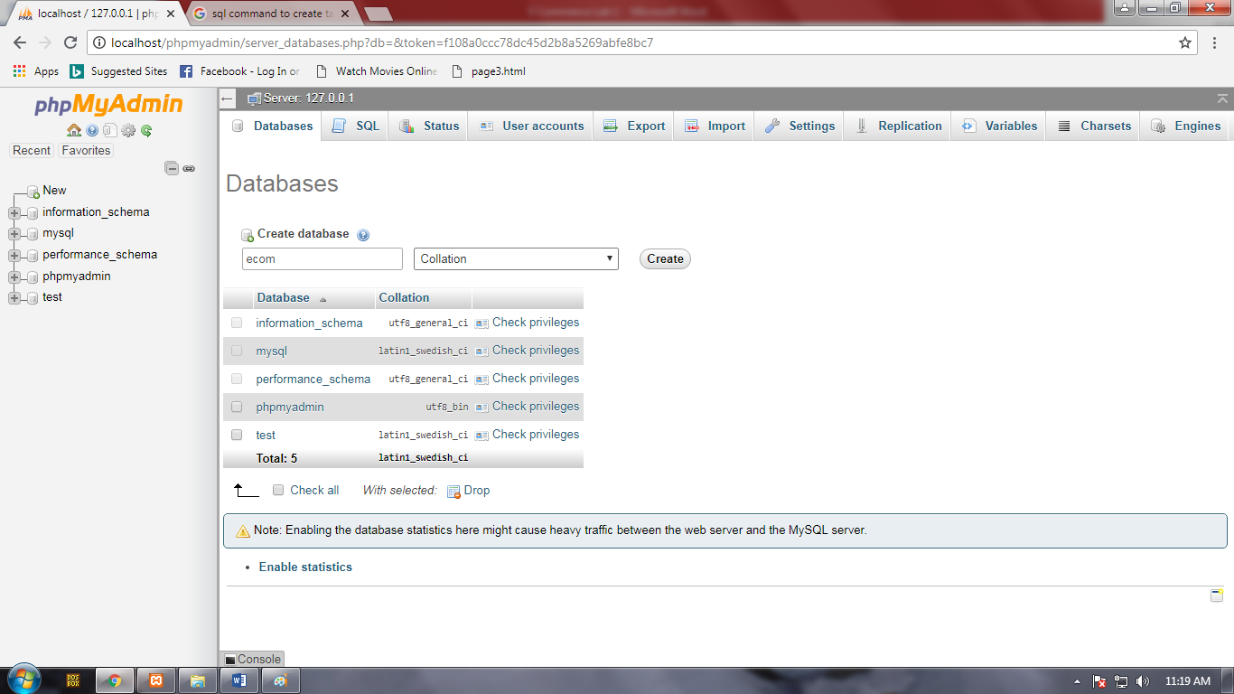

* Create a database “ecom”

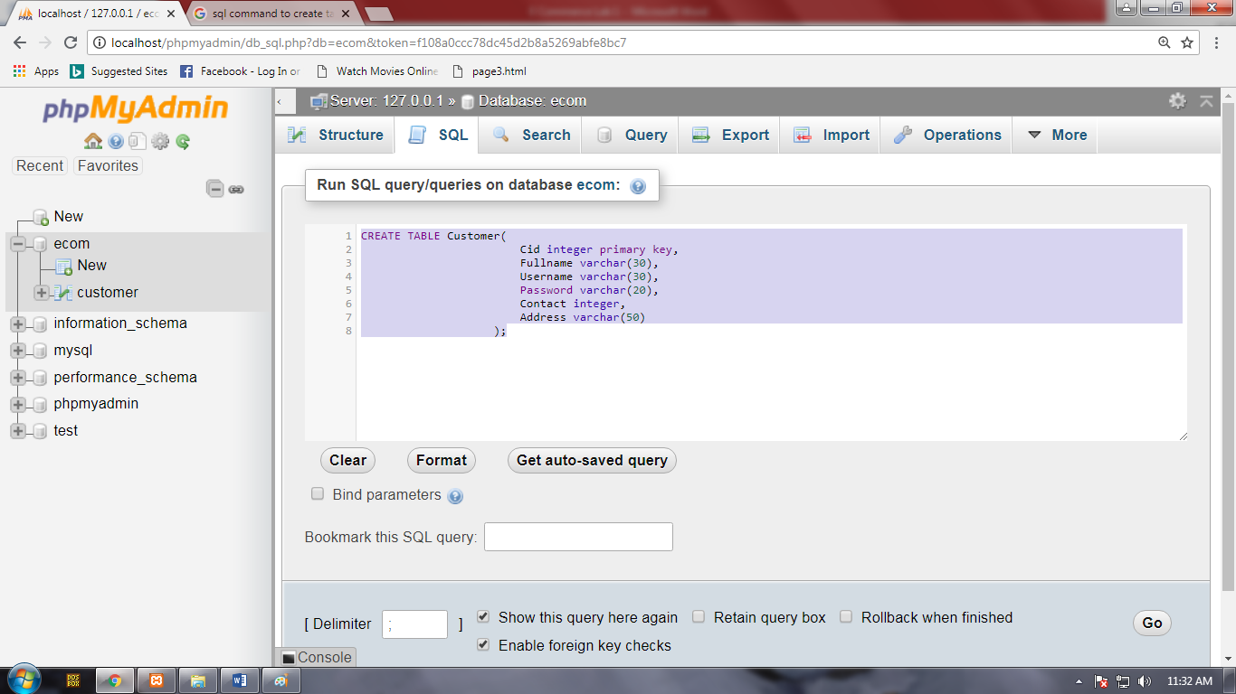

* Create a table “Customer” in db “ecom”.

*CREATE TABLE Customer(*

*Cid integer primary key,*

*Fullname varchar(30),*

*Username varchar(30),*

*Password varchar(20),*

*Contact integer,*

*Address varchar(50)*

*);*

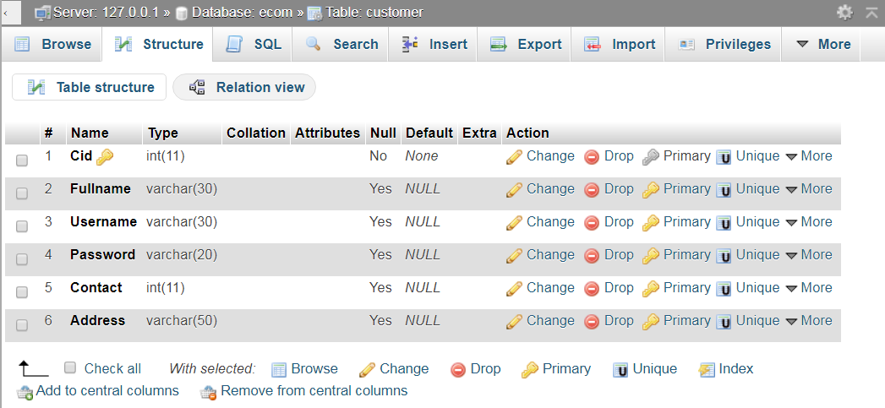

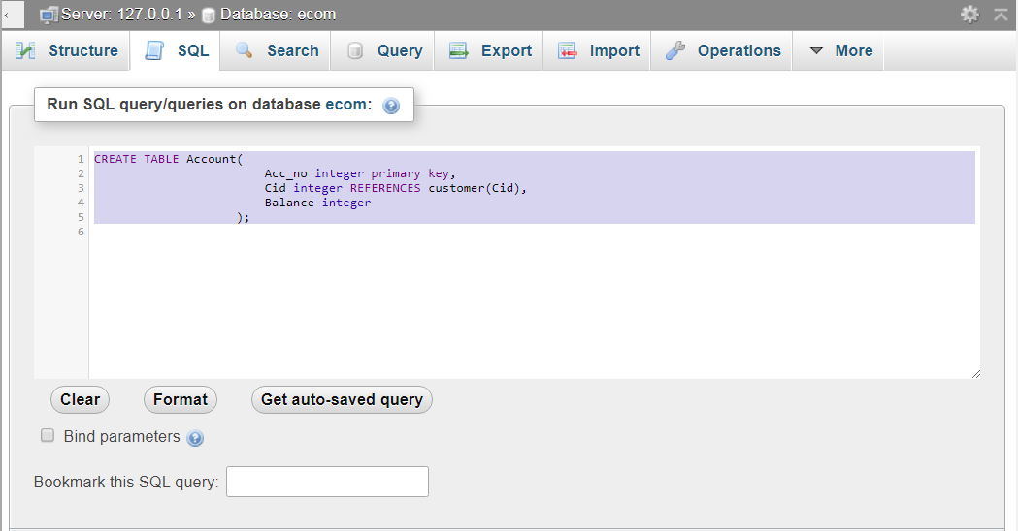

* Create a table “Account” in db “ecom”.

*CREATE TABLE Account(*

*Acc_no integer primary key,*

*Cid integer REFERENCES customer(Cid),*

*Balance integer*

*);*

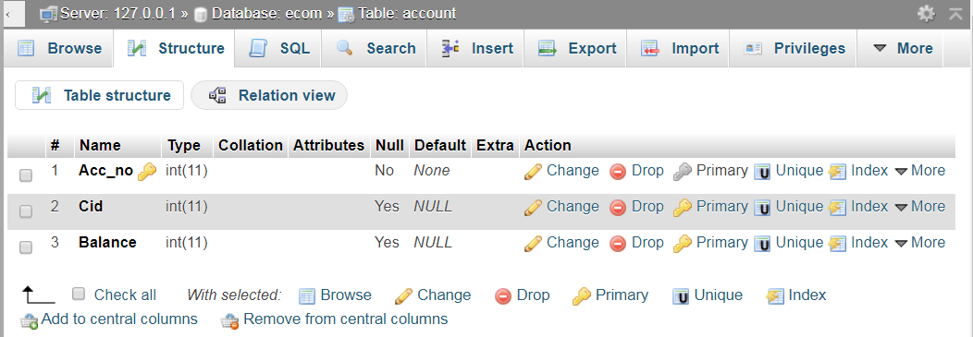

* Insert values in tables.

*INSERT INTO `customer`(`Cid`, `Fullname`, `Username`, `Password`, `Contact`, `Address`) VALUES ('001','Manil Singha Malla','Wolf Crecent','Alohomora','9803983868','Maitedevi')*

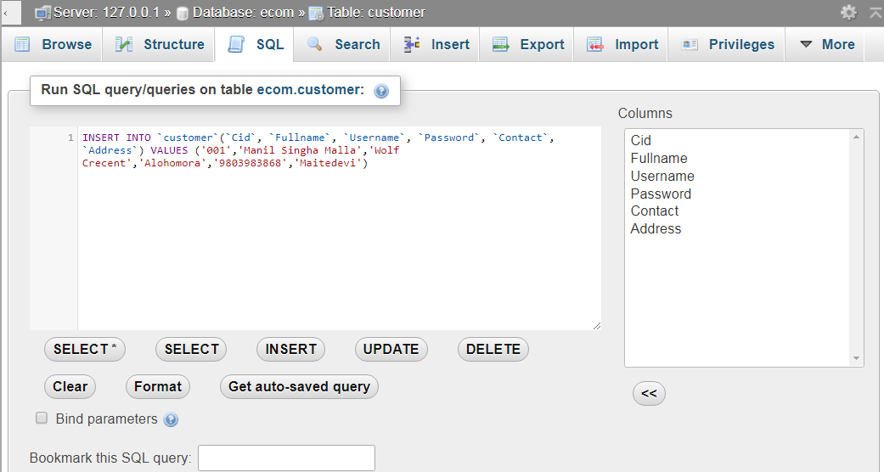

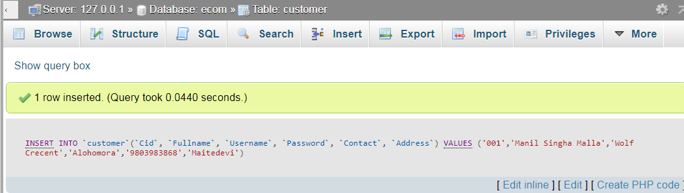

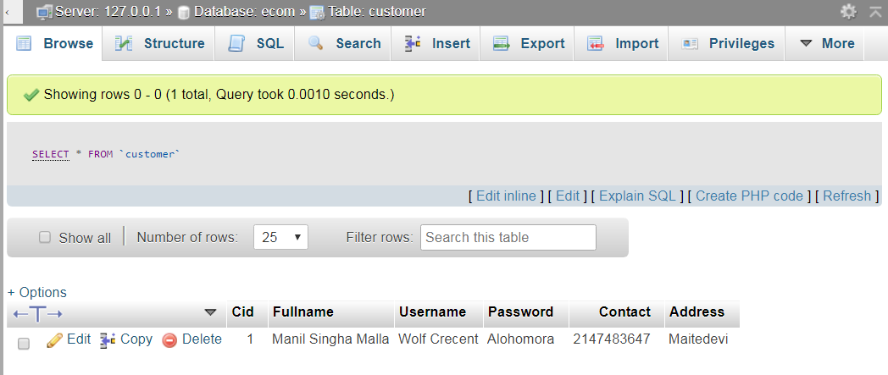

*INSERT INTO `account`(`Acc_no`, `Cid`, `Balance`) VALUES (123456,'001','50000')*

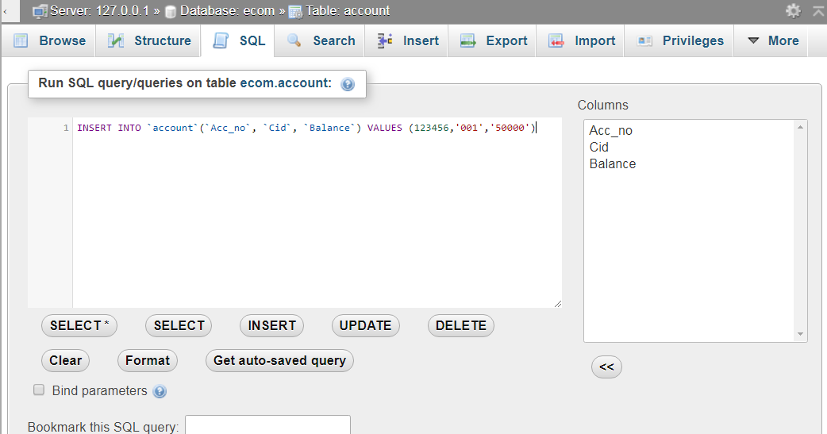

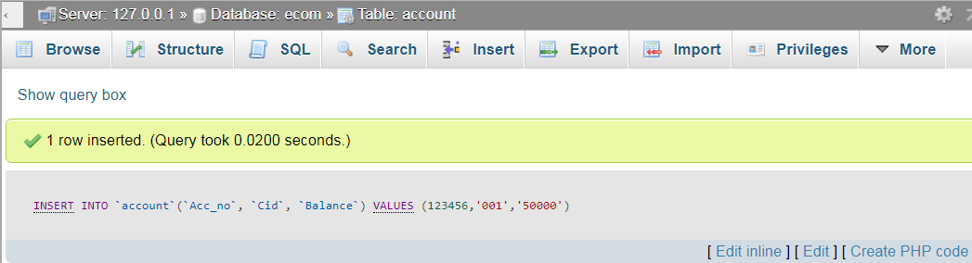

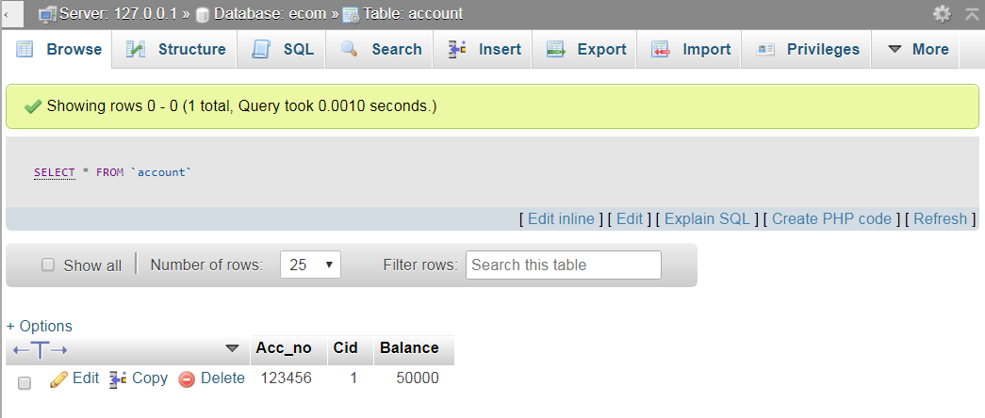

* Error

